Telco Customer Churn Analysis

1. Project Overview
The Telco Customer Churn Analysis project was designed to identify the key factors that lead to customer attrition in a telecommunications company. By analyzing service usage, contract terms, and billing methods, the project provides data-driven recommendations to improve customer retention.

2. Technical Workflow
A. Data Cleaning & Preprocessing (Python)
Using Jupyter Notebook, the raw data underwent a rigorous cleaning process to ensure accuracy:
- Library Integration: Utilized pandas and numpy for data manipulation.
- Type Casting: Converted the TotalCharges column from a string (object) to a numeric float to enable mathematical analysis.
- Missing Value Management: Identified 11 null values in TotalCharges caused by new customers with a tenure of 0.
- Data Consistency: Removed records with 0 tenure to ensure the analysis focused on established customer behavior, resulting in a final dataset of 7,032 records.
B. Database Integration (SQL)
The cleaned data was migrated into a MySQL database via sqlalchemy to perform high-performance relational queries.

3. Key Insights and Analysis
A. Contract Types & Risk Assessment
Contract duration is the primary indicator of churn risk.
- Month-to-Month: This group represents the highest risk with 1,655 churned customers, accounting for a churn rate of approximately 42.7%.
- One-Year Contracts: Showed significantly better retention with only 166 churns.
- Two-Year Contracts: Demonstrated the highest loyalty with only 48 churns out of 1,685 customers.
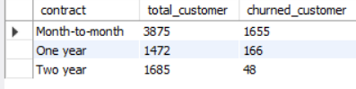
B. Internet Service Impact
The technology provided to the customer correlates strongly with their likelihood to leave.
- Fiber Optic: Suffers from the highest churn volume with 1,297 customers leaving.
- DSL: Maintains a more stable base with 459 churns.
- No Internet Service: Shows the lowest churn, suggesting these customers may be less sensitive to competitive service offers.
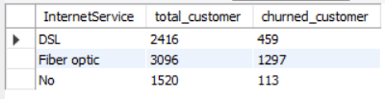
C. The Value of Technical Support
Providing proactive support is a key retention tool.
- High Risk: Customers with no TechSupport saw 1,446 churns.
- Low Risk: Customers with TechSupport only saw 310 churns, proving that assistance significantly increases customer lifetime value.
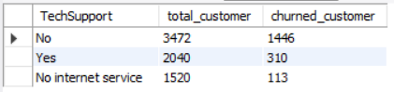

4. Dashboard in Power BI
Finally, we built an interactive dashboard in Power BI to present insights visually.
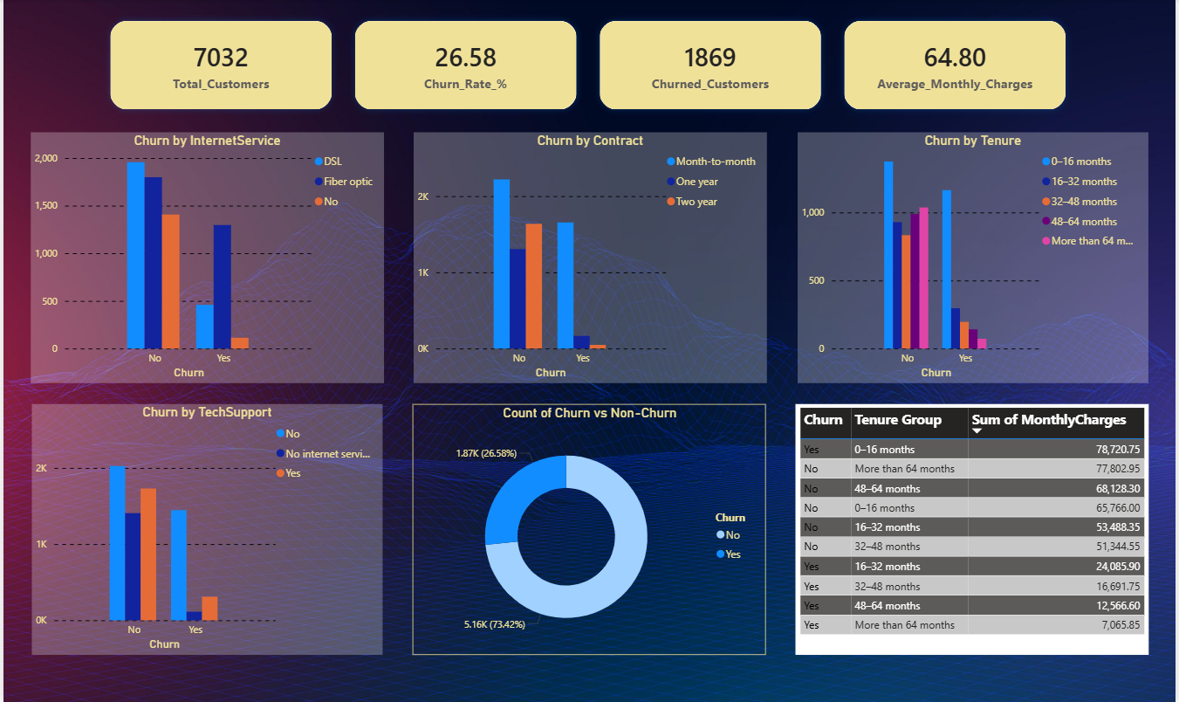

5. Recommendations
- Incentivize Long-Term Contracts: Offer discounts or service upgrades to migrate "Month-to-Month" customers to at least a one-year plan.
- Fiber Optic Quality Audit: Investigate why Fiber Optic customers are churning at a higher rate compared to DSL.
- Support Upselling: Package "TechSupport" as a standard feature or a low-cost add-on to reduce service-related frustration.

6. Tools Used
- Python: Data cleaning and handling missing values.
- SQL (MySQL): Complex data aggregation and churn rate calculation.
- Pandas/NumPy: Feature engineering and data type conversion.
- Power BI: Power BI was used to create an interactive dashboard that transforms cleaned data into visual KPIs and charts, highlighting critical churn drivers like contract types and service categories for stakeholder reporting.

